Day 26 - 13th Aug 2025

Creational
Structural DP
Behavioural

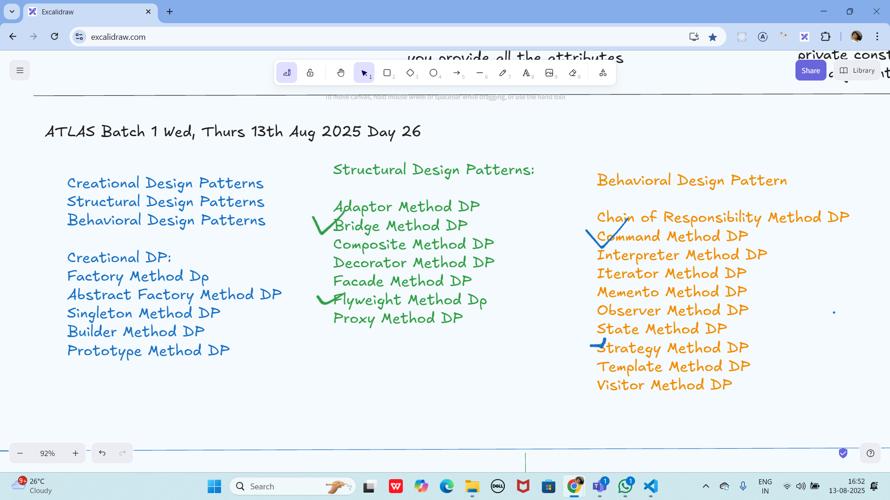

Strategy Method Dp → Behavioral

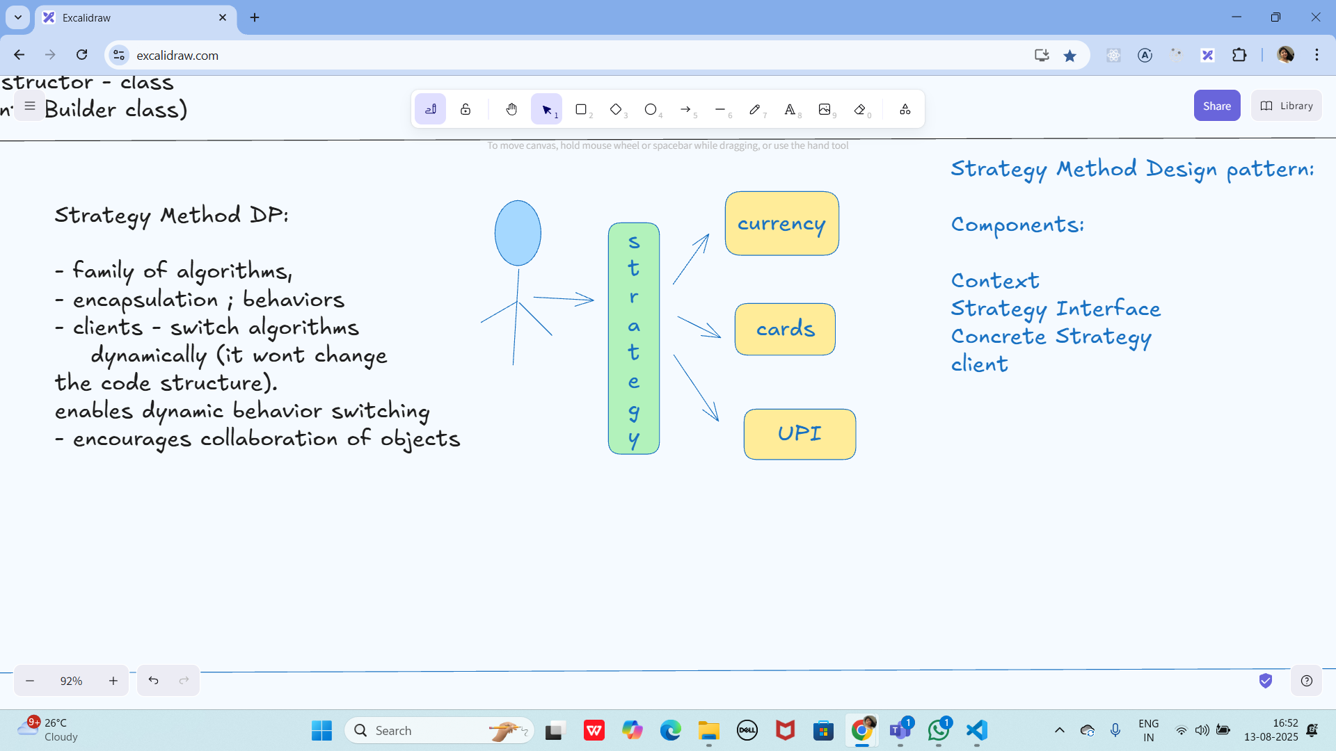

Command method DP → Behavioural

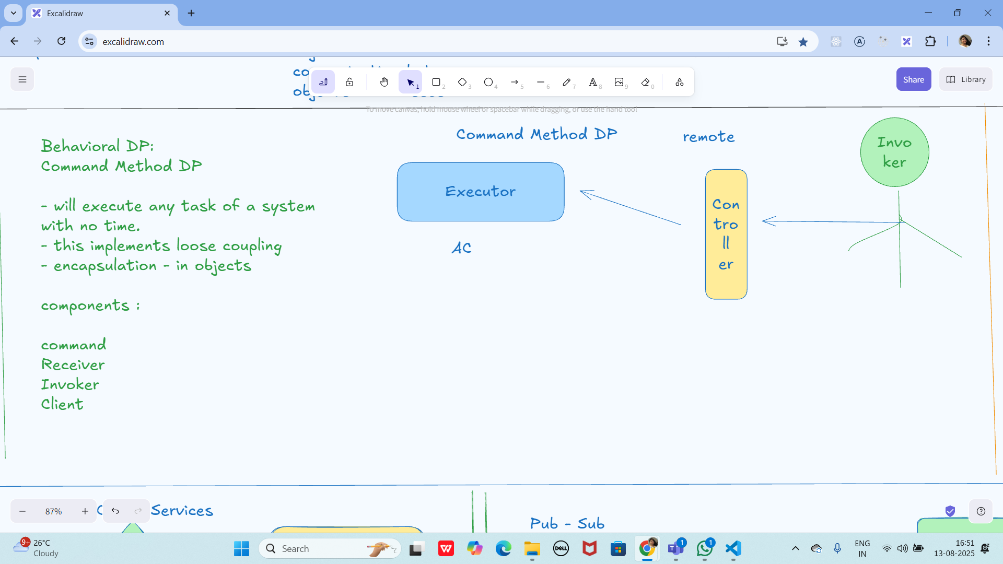

Microservices:
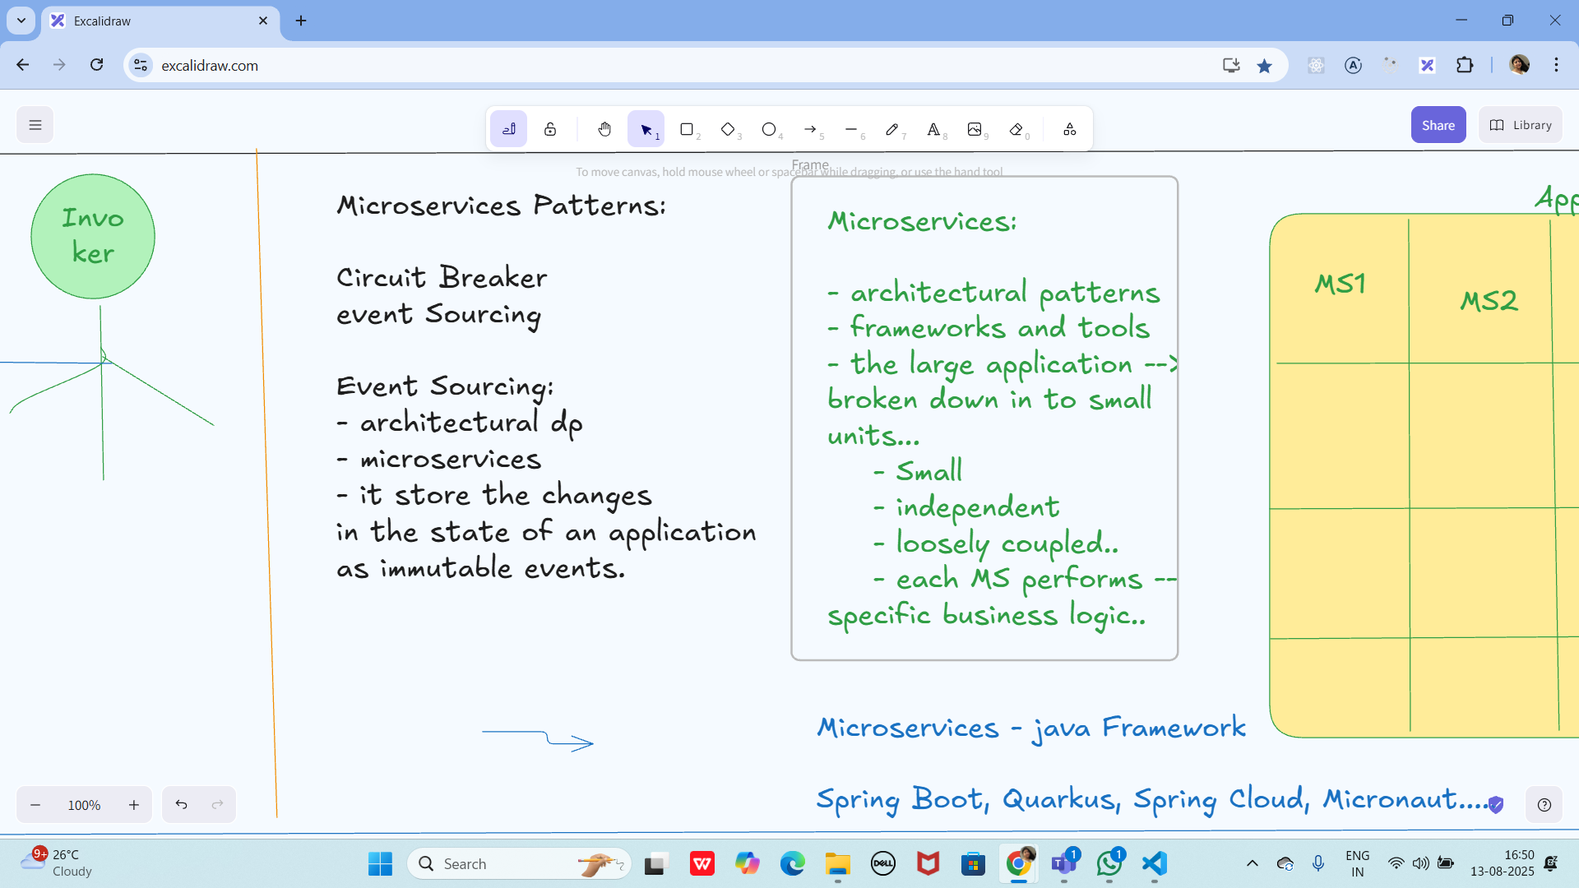

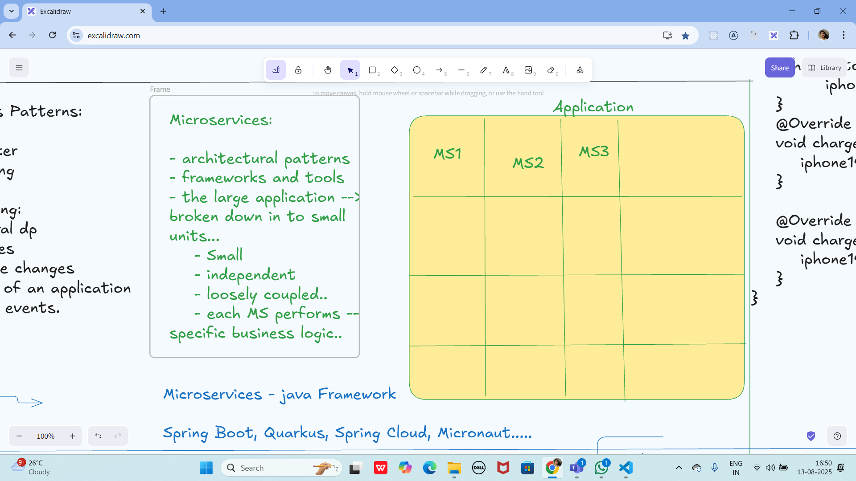

Event source Pattern

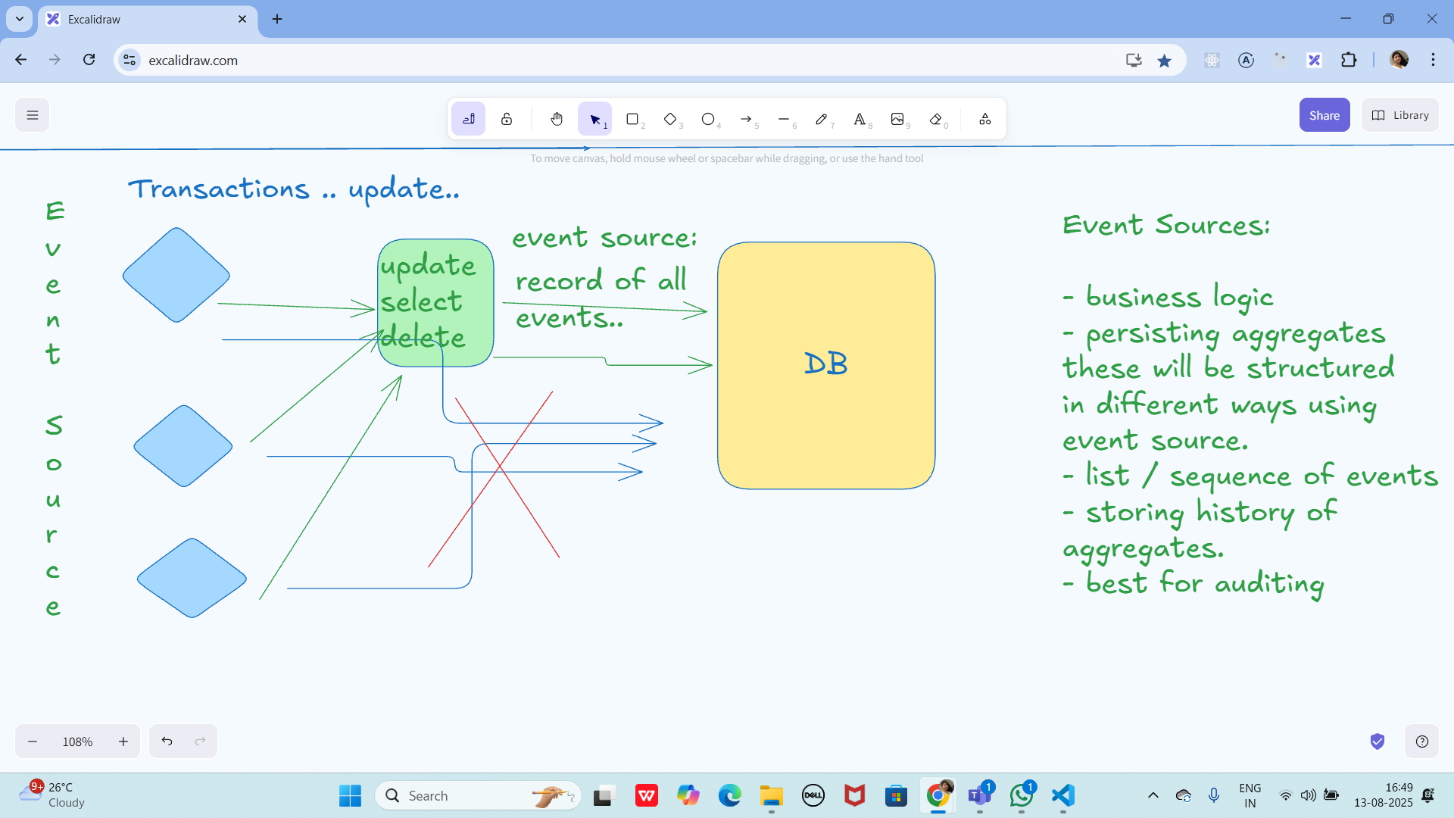

Circuit Breaker Pattern

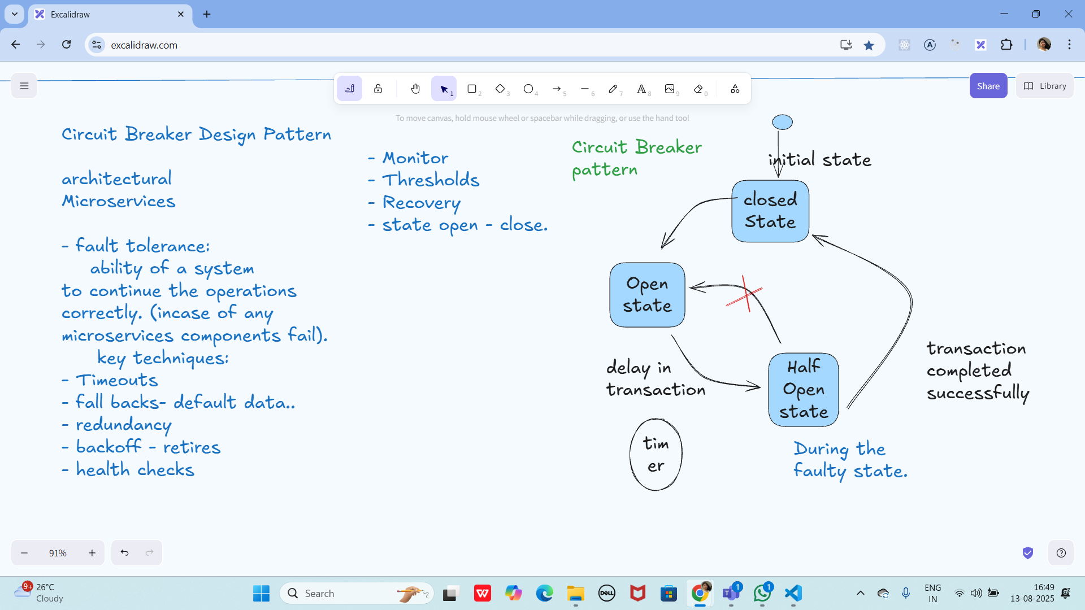

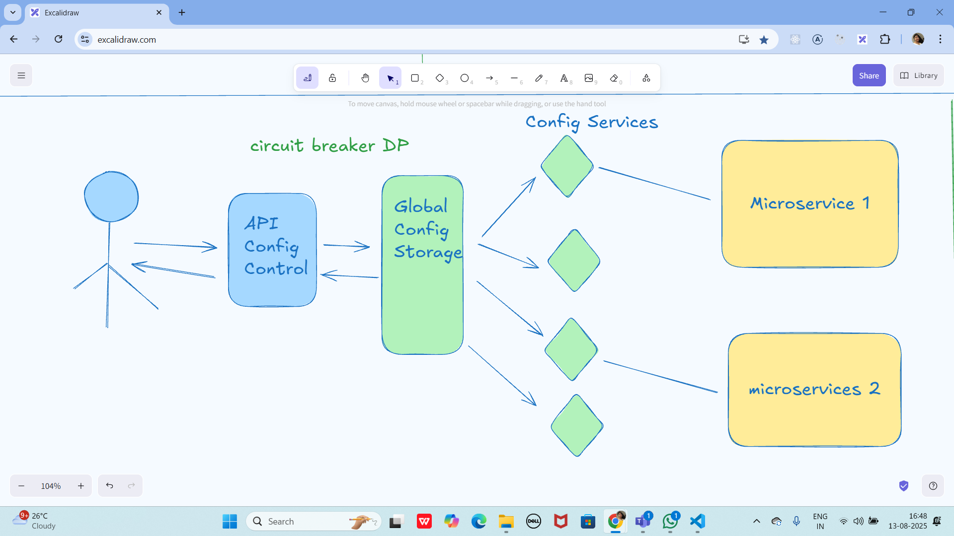

Pub sub Pattern:

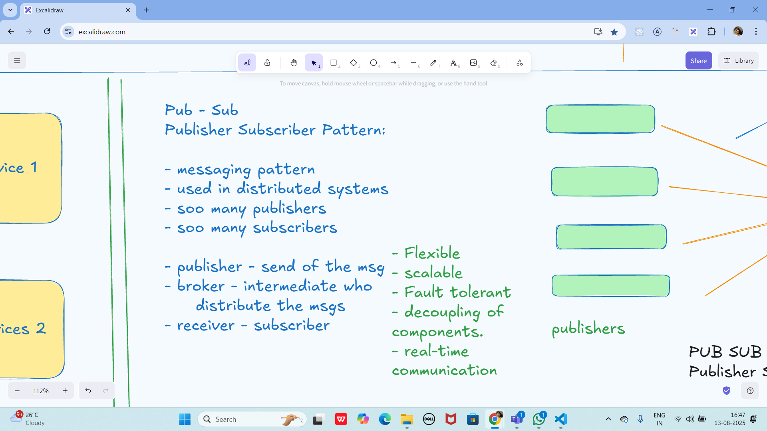

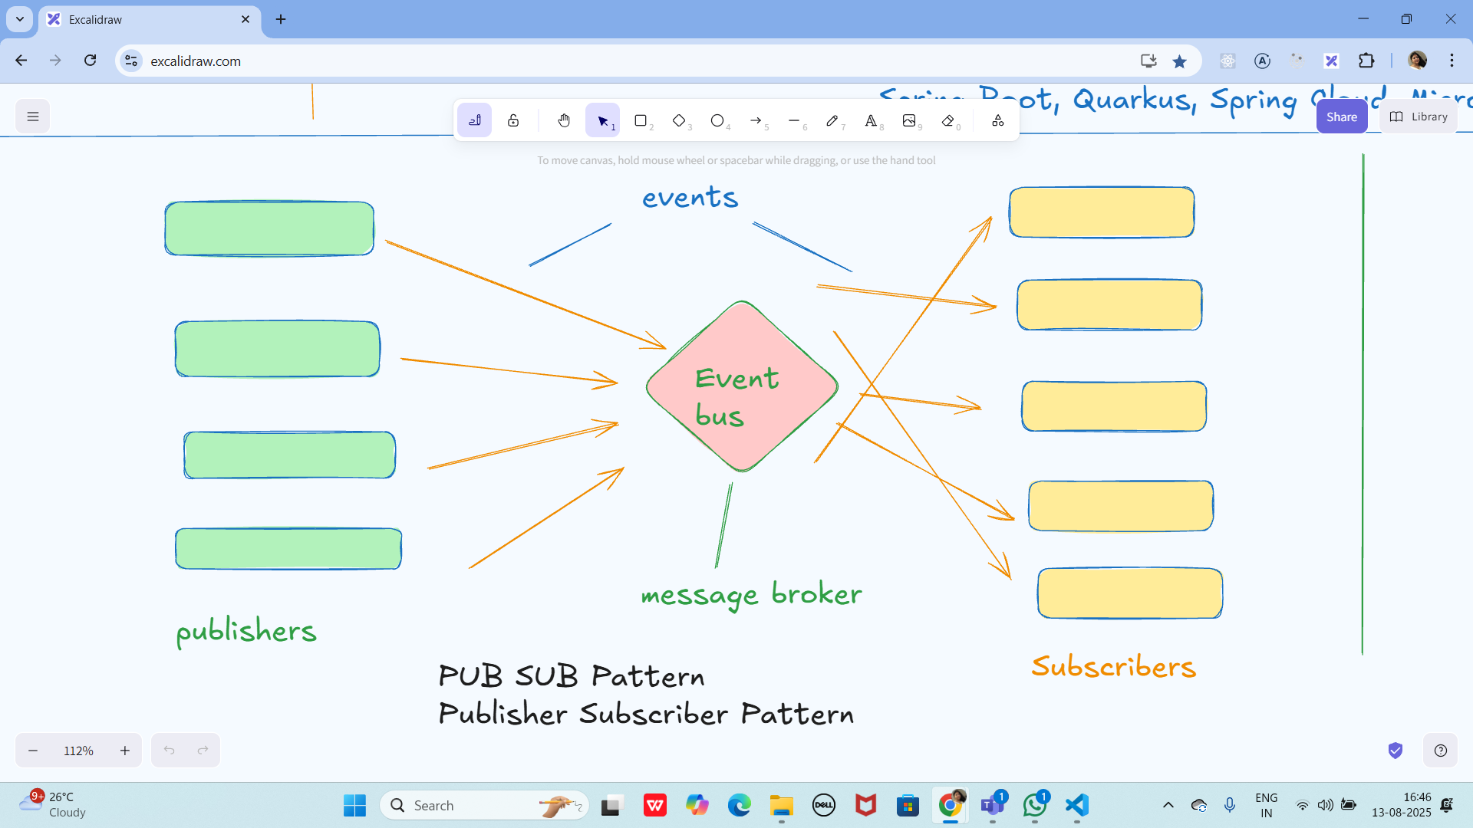

Three tier Architecture

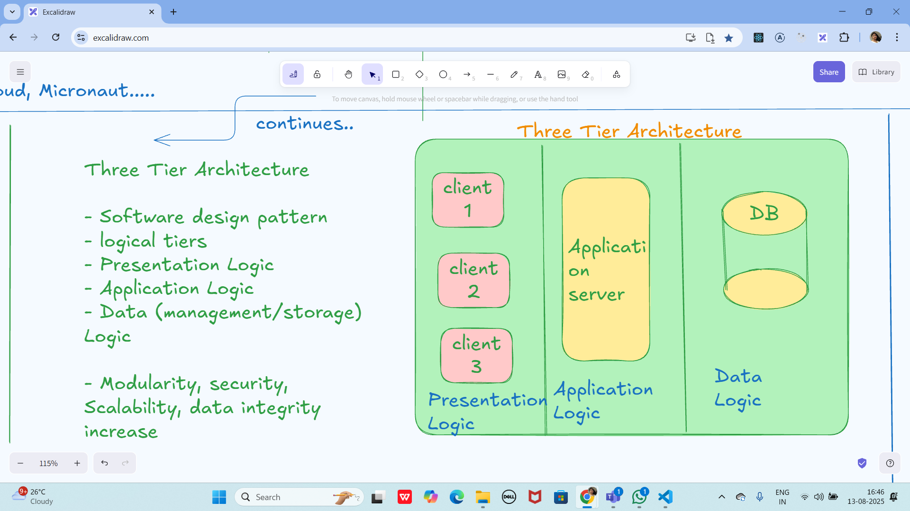

Multi tier Architecture

Multi Tier Architecture
=> client - server architecture

- improved scalability
-

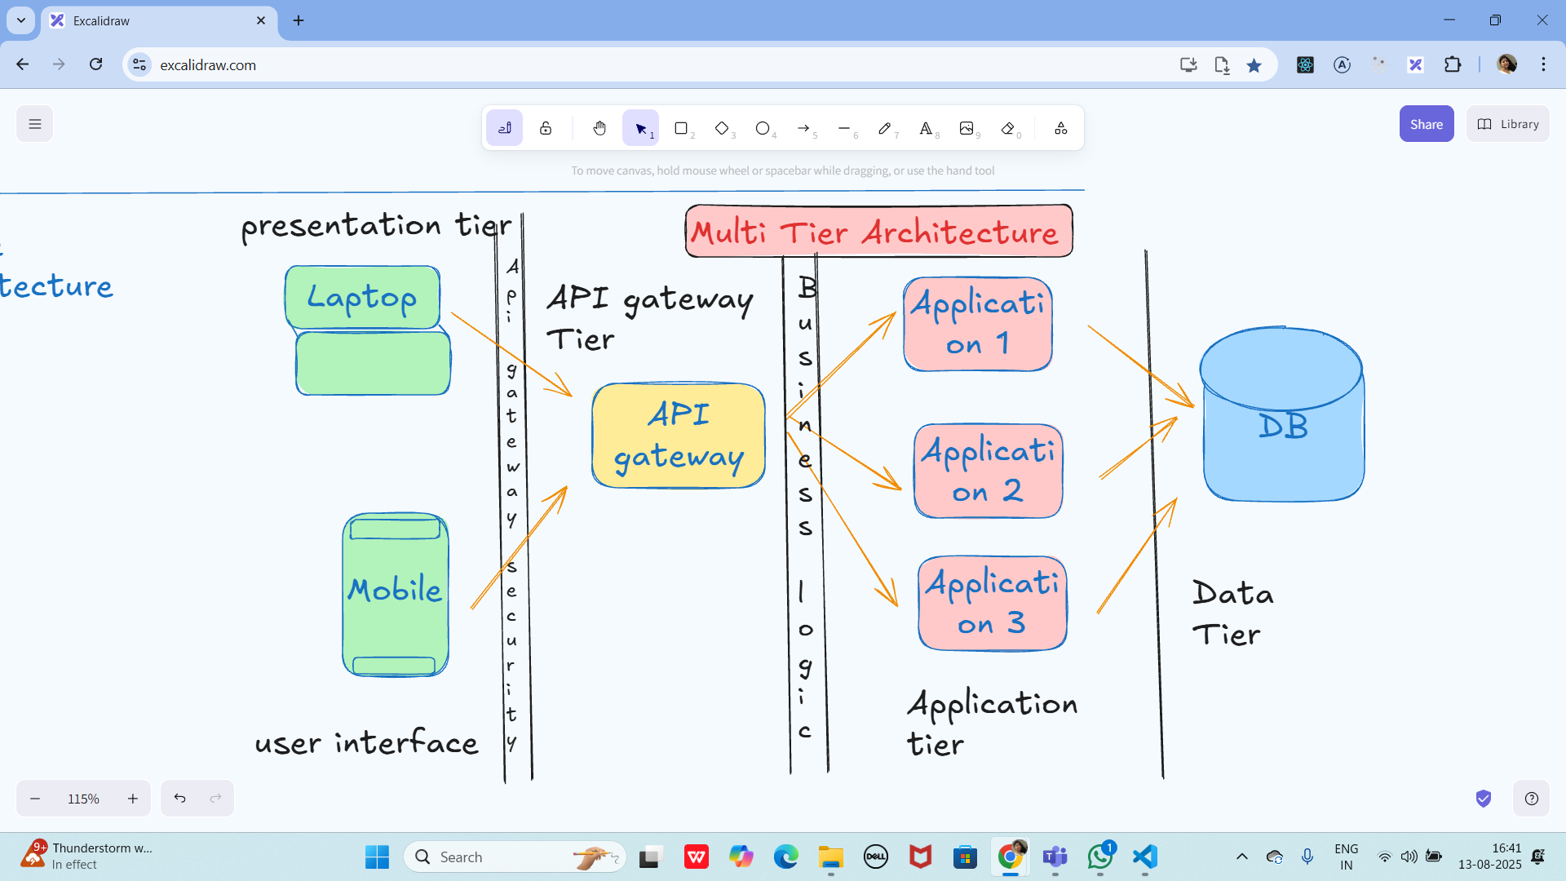

Task 01:
What are the Advantages of Multi tier Architecture?

Multi-tier architecture (also called n-tier architecture) is a software design pattern that separates an application into multiple logical layers or tiers, such as presentation layer, business logic layer, and data layer. This separation provides several key benefits:

1. Separation of Concerns
Each tier has a well-defined responsibility:
- Presentation layer handles the user interface.
- Business logic layer processes rules and workflows.
- Data layer manages storage and retrieval.
This separation makes the system easier to understand, maintain, and extend.

2. Scalability
Each tier can be scaled independently depending on demand.
For example:
- Add more servers to the data tier for heavy database operations.
- Add more servers to the presentation tier for handling high user traffic.

3. Reusability
Business logic and data access layers can be reused across multiple applications (e.g., web, mobile, and desktop applications can all use the same backend services).

4. Maintainability
Since each layer is independent, changes in one layer (e.g., UI redesign) don’t affect the others (e.g., database or business rules). This makes bug fixing and feature enhancements easier.

5. Security
Multi-tier architecture allows better enforcement of security:
- Sensitive data is kept in the data tier.
- Access to the business layer can be restricted and validated.
- Presentation layer exposes only what the user needs.

6. Flexibility & Technology Independence
Different tiers can use different technologies best suited for their role.
Example:
- UI (React, Angular)
- Business logic (Java, .NET, Spring Boot)
- Database (MySQL, DynamoDB, MongoDB)

7. Performance Optimization
Each tier can be tuned and optimized separately (e.g., caching at the business layer, indexing at the data layer).

✅ In summary:
Multi-tier architecture improves scalability, maintainability, reusability, security, and flexibility, making it one of the most widely adopted architectural patterns for enterprise applications.

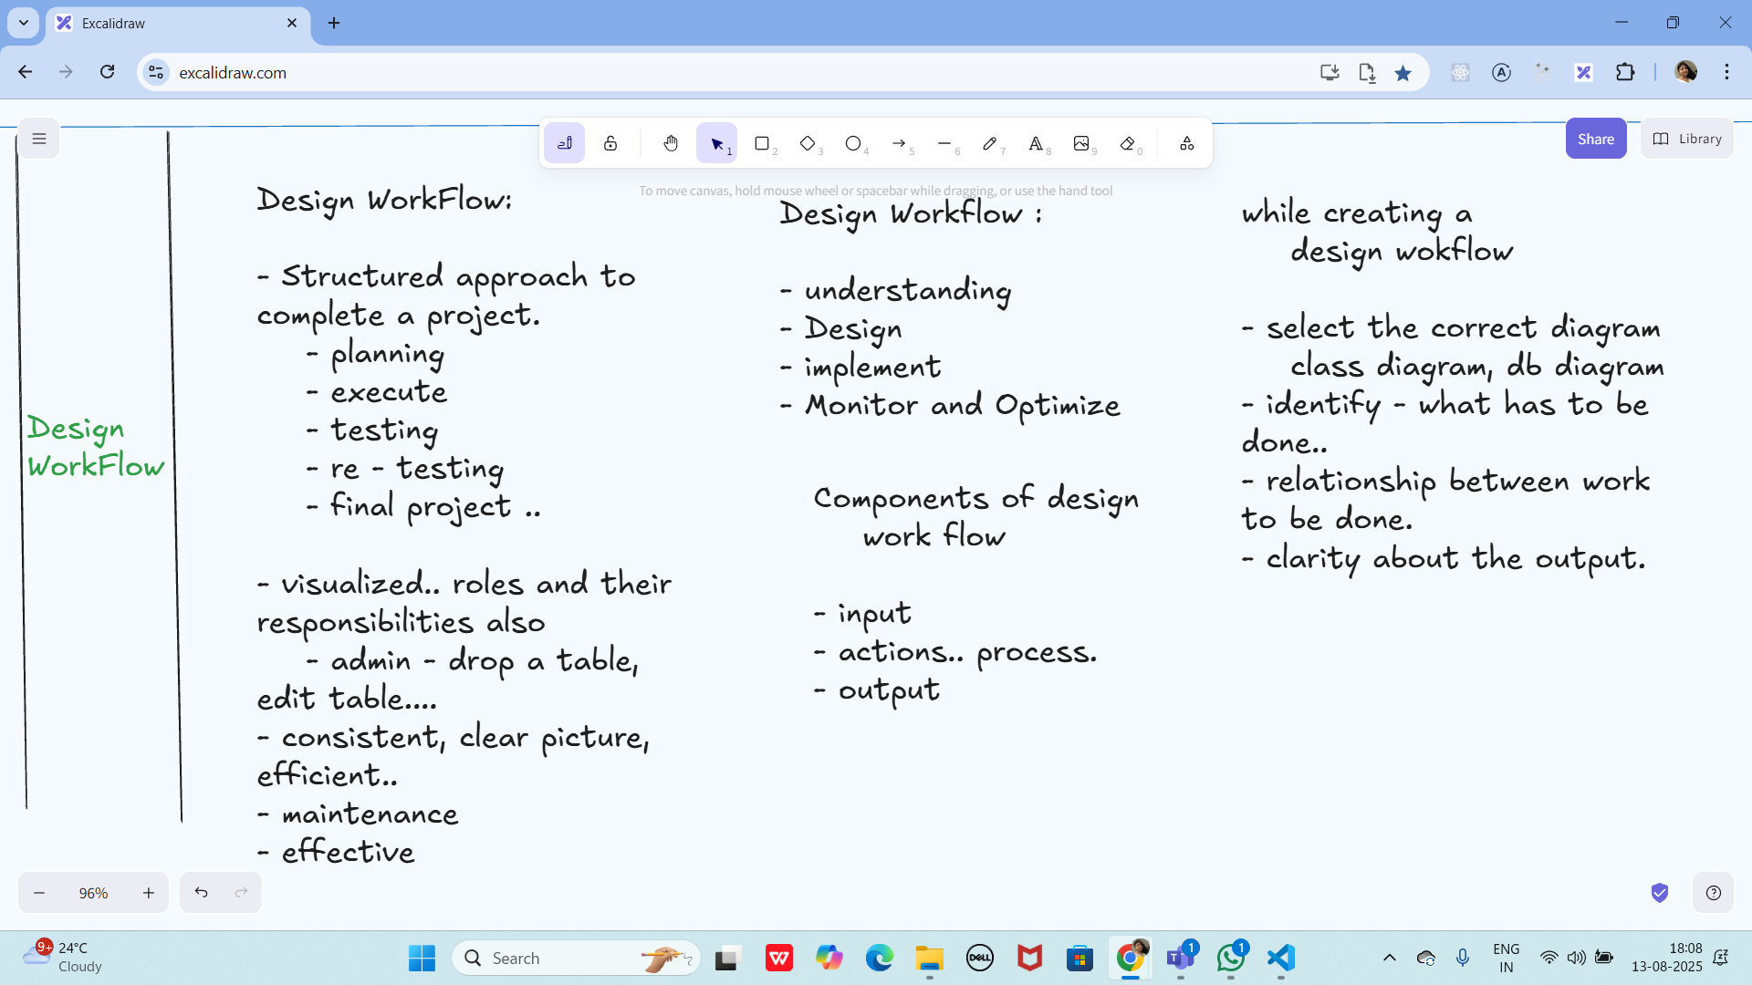

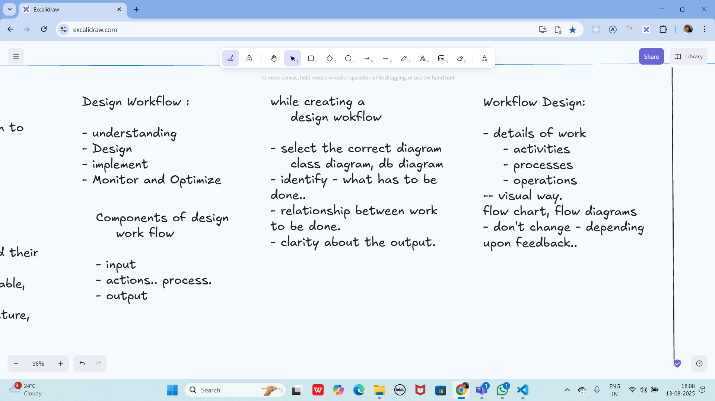

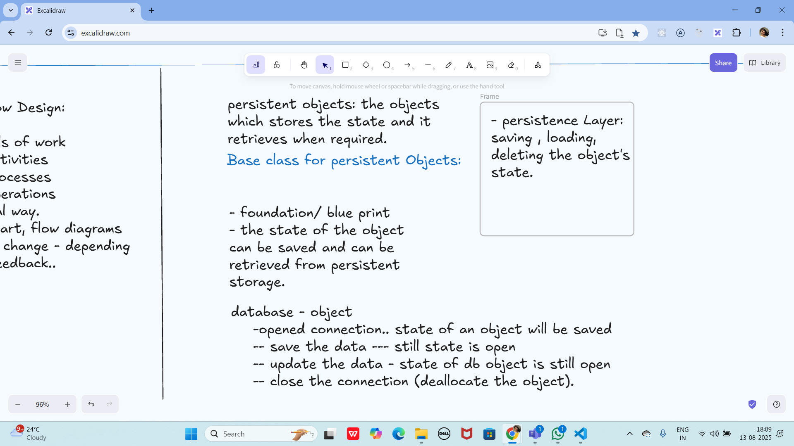

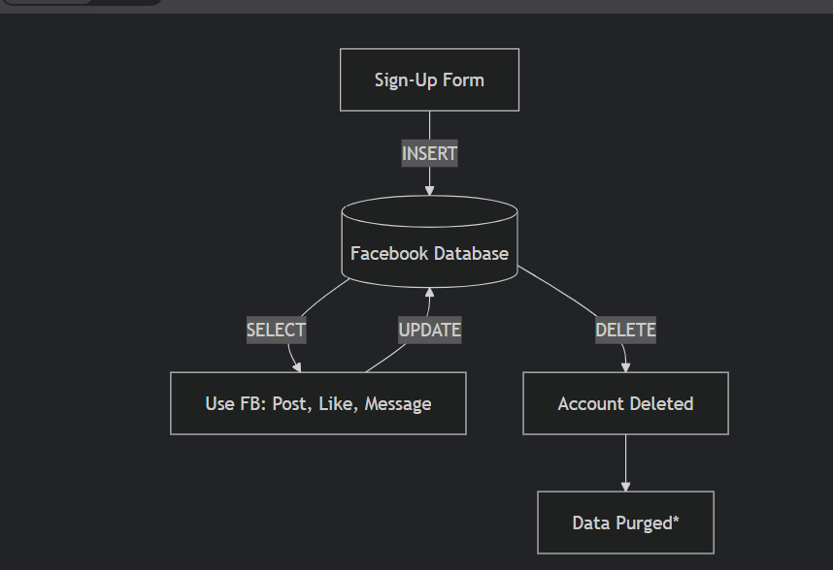

+++++++++++++++++++++++++++++++++++++++++++++++++++++++++++++++++++++++++++++++++++++++++++++++++++++++++++++++++++++++++++++++++++++++++++

Home Tasks:

Behavioral Dp: 1 . Strategy
// Strategy Interface
interface PaymentStrategy {
void pay(int amount);
}

// Concrete Strategy 1
class CreditCardPayment implements PaymentStrategy {
private String cardNumber;

public CreditCardPayment(String cardNumber) {
this.cardNumber = cardNumber;
}

public void pay(int amount) {
System.out.println("Paid " + amount + " using Credit Card: " + cardNumber);
}
}

// Concrete Strategy 2
class PayPalPayment implements PaymentStrategy {
private String email;

public PayPalPayment(String email) {
this.email = email;
}

public void pay(int amount) {
System.out.println("Paid " + amount + " using PayPal account: " + email);
}
}

// Context
class PaymentContext {
private PaymentStrategy strategy;

public void setPaymentStrategy(PaymentStrategy strategy) {
this.strategy = strategy;
}

public void checkout(int amount) {
strategy.pay(amount);
}
}

// Client
public class StrategyDemo {
public static void main(String[] args) {
PaymentContext context = new PaymentContext();

// Using Credit Card
context.setPaymentStrategy(new CreditCardPayment("1234-5678-9012"));
context.checkout(100);

// Using PayPal
context.setPaymentStrategy(new PayPalPayment("ajay@example.com"));
context.checkout(200);
}
}

2. command method

// Command Interface
interface Command {
void execute();
}

// Receiver
class Light {
public void turnOn() {
System.out.println("Light is ON");
}

public void turnOff() {
System.out.println("Light is OFF");
}
}

// Concrete Command 1
class LightOnCommand implements Command {
private Light light;

public LightOnCommand(Light light) {
this.light = light;
}

public void execute() {
light.turnOn();
}
}

// Concrete Command 2
class LightOffCommand implements Command {
private Light light;

public LightOffCommand(Light light) {
this.light = light;
}

public void execute() {
light.turnOff();
}
}

// Invoker
class RemoteControl {
private Command command;

public void setCommand(Command command) {
this.command = command;
}

public void pressButton() {
command.execute();
}
}

// Client
public class CommandDemo {
public static void main(String[] args) {
Light livingRoomLight = new Light();

// Create commands
Command lightOn = new LightOnCommand(livingRoomLight);
Command lightOff = new LightOffCommand(livingRoomLight);

// Invoker
RemoteControl remote = new RemoteControl();

// Turn ON
remote.setCommand(lightOn);
remote.pressButton();

// Turn OFF
remote.setCommand(lightOff);
remote.pressButton();
}
}

Task 03:

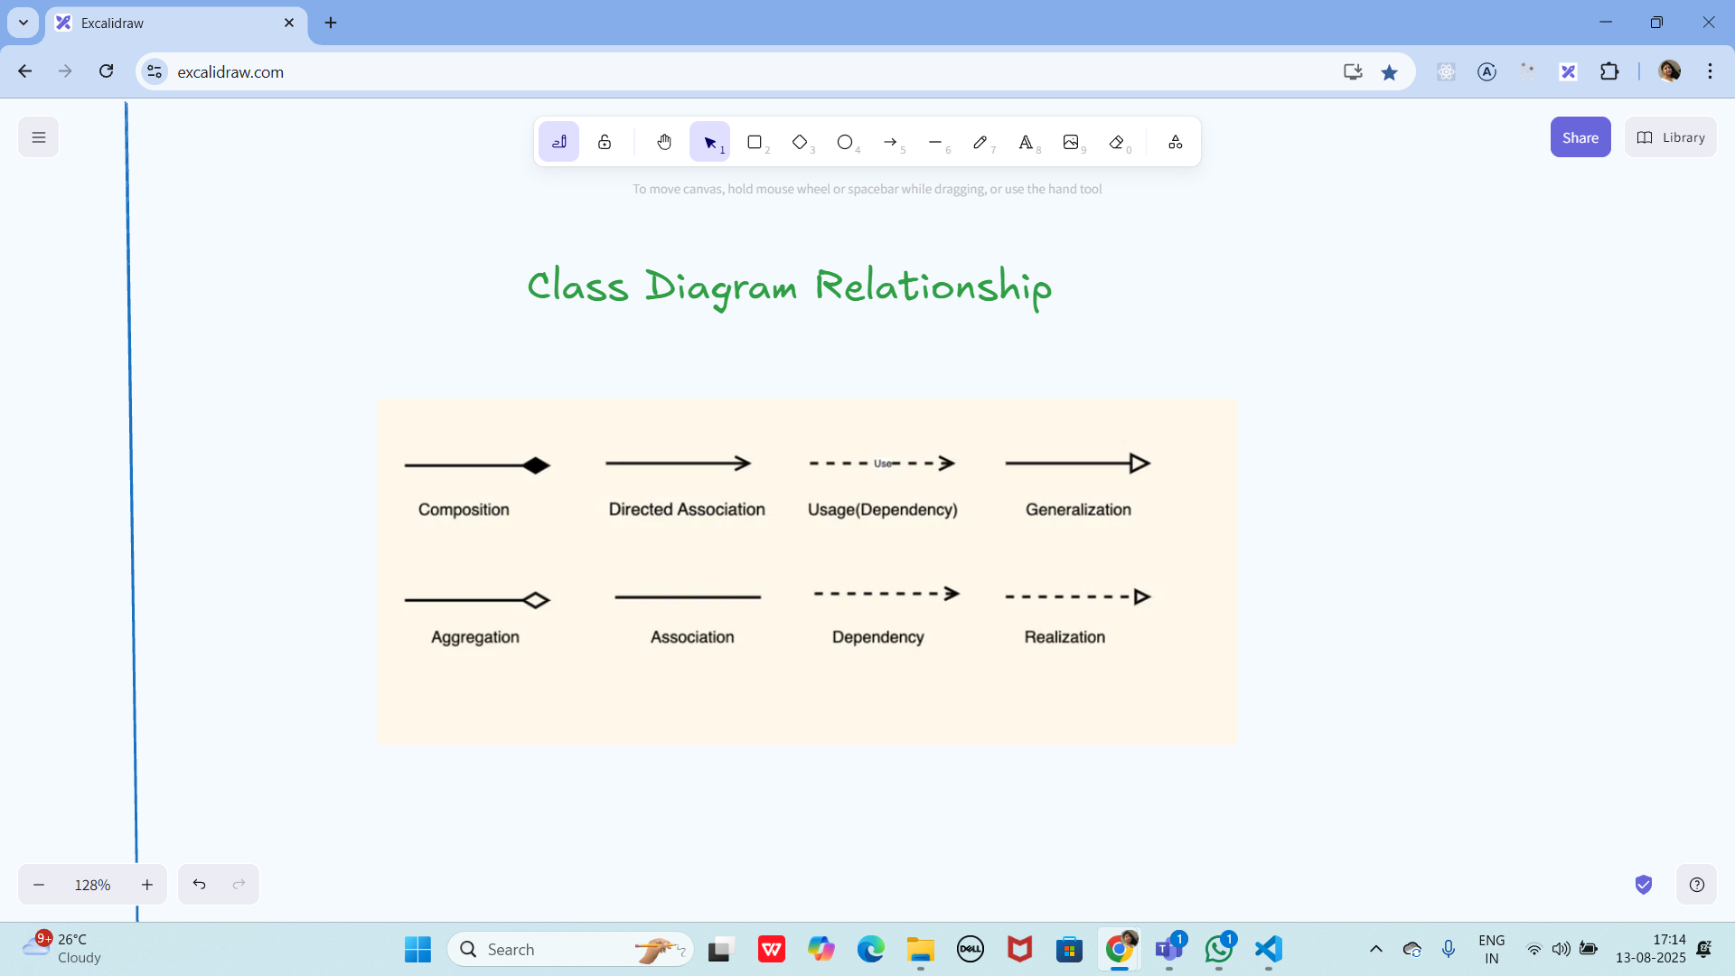

Task 04:

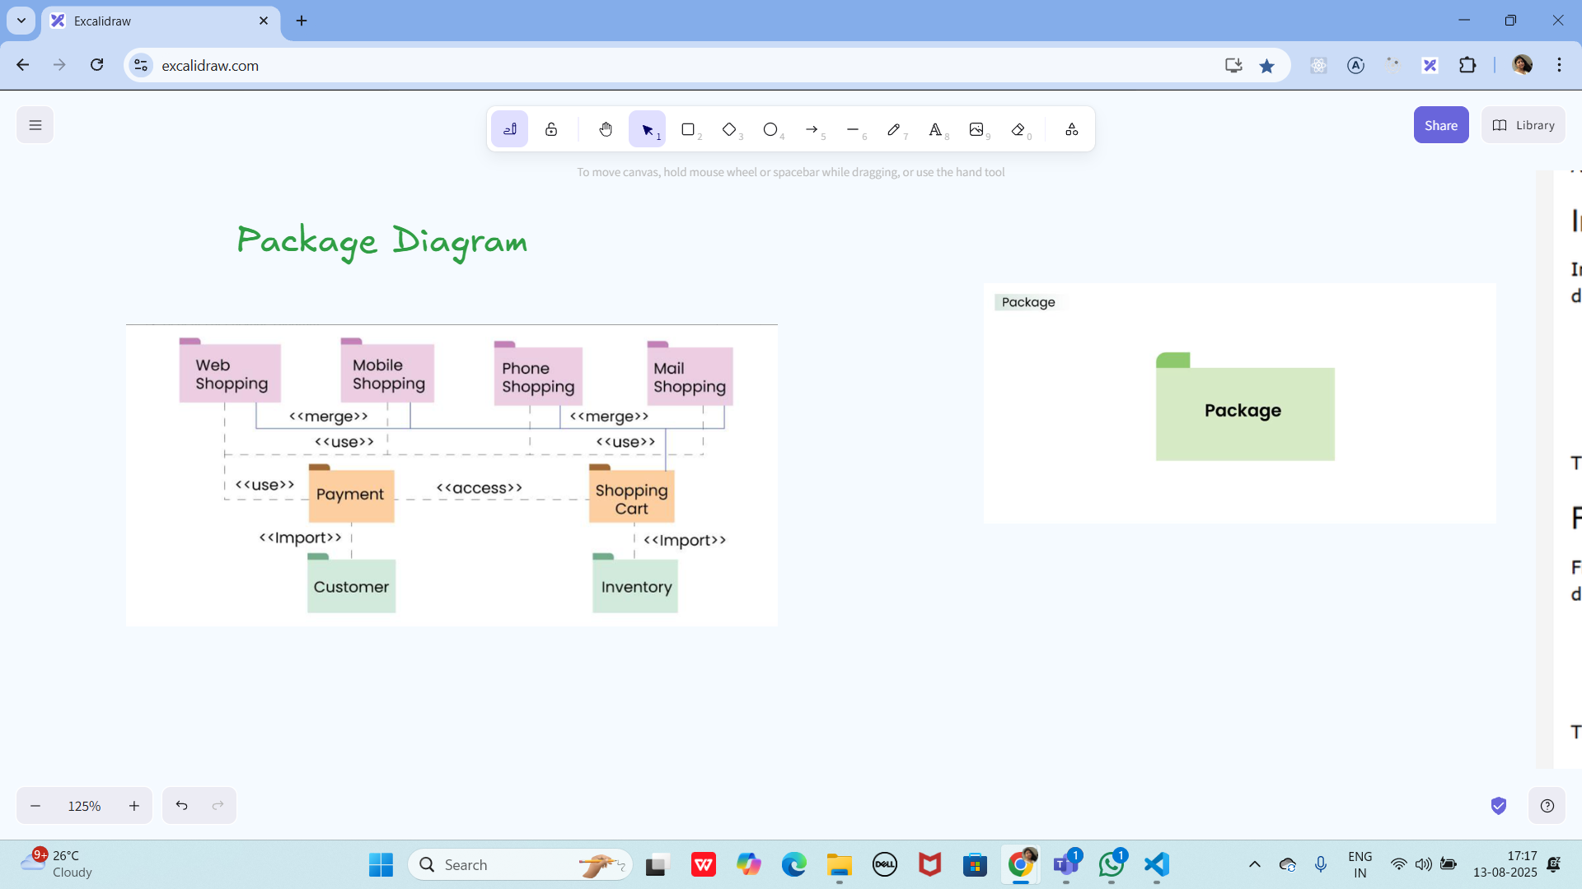

Create a package diagram representation of Command Design Pattern code..

@startuml PackageDiagram
package "command" {
[Command]
[LightOnCommand]
[LightOffCommand]
}

package "receiver" {
[Light]
}

package "invoker" {
[RemoteControl]
}

package "client" {
[CommandDemo]
}

[LightOnCommand] --> [Light] : uses
[LightOffCommand] --> [Light] : uses
[RemoteControl] --> [Command] : depends on
[CommandDemo] --> [RemoteControl] : creates
[CommandDemo] --> [Light] : creates
@enduml

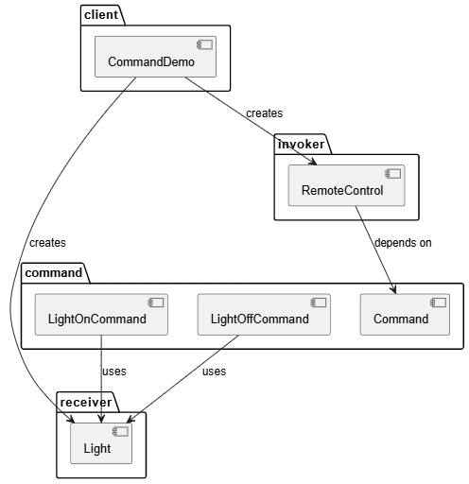

Task 05:

Info 👍

Understand diff between

Rating Qns:

3. Which of the following components is not typically part of the Command pattern?
a) Invoker
b) Receiver
c) Abstract Factory
d) Command (interface/abstract class)

What role does the Invoker play in the Command pattern?
a) It knows how to perform the operations associated with a request.
b) It encapsulates the request as an object.
c) It asks the command to carry out the request.
d) It defines the interface for executing an operation.

A key benefit of using the Command pattern is its ability to support:
a) Lazy initialization
b) Undo/Redo functionality
c) Singleton instance creation
d) Compile-time polymorphism

In the Strategy pattern, what role does the "Context" play?
A. It defines the interface for the algorithms.
B. It implements a specific algorithm.
C. It maintains a reference to a Strategy object and delegates the task to it.
D. It creates the Concrete Strategy objects.

**************************************************************************************************************************************************************************************************************************

Info Box:

Strategy Method DP:

Codes for reference link is below

https://drive.google.com/drive/folders/1LwhNov1s1-vHzF9GPAObLSnP9kAvipmw?usp=sharing

Code can be found in → Codes for reference → OOAD → Strategy Method DP.

Command Method DP code in Codes for reference

Excalidraw link updated at 11.50:

https://excalidraw.com/#json=ApYmKVfT4c0BbWs8y2EOe,UpLAw9RgWj4HgxdaMOC0xQ

Excalidraw link updated at 13.23

https://excalidraw.com/#json=mftMxEg5jjIXA5eVC7b-i,DVNKX2PvMsB8ZVkKc0CNuQ
Publisher Subscriber Pattern code in code for reference

Excalidraw link updated at 16.44

https://excalidraw.com/#json=aV6jajpxgU0LHxFWvmRy1,2HM5gvVCmTa5_wGXMTZc2A

Exca;lidraw link updated at 18.05

https://excalidraw.com/#json=4WkZ9xQ3_vqnQxofqOAGs,18EhyeE8wgYKq-kWm2xjmA

**************************************************************************************************************************************************************************************************************************

